While Cynthia is away, let’s put together a note for the approach lecture and the office hours! Please add to this whatever you feel is relevant (especially screenshots)! Thanks in advance, team :)

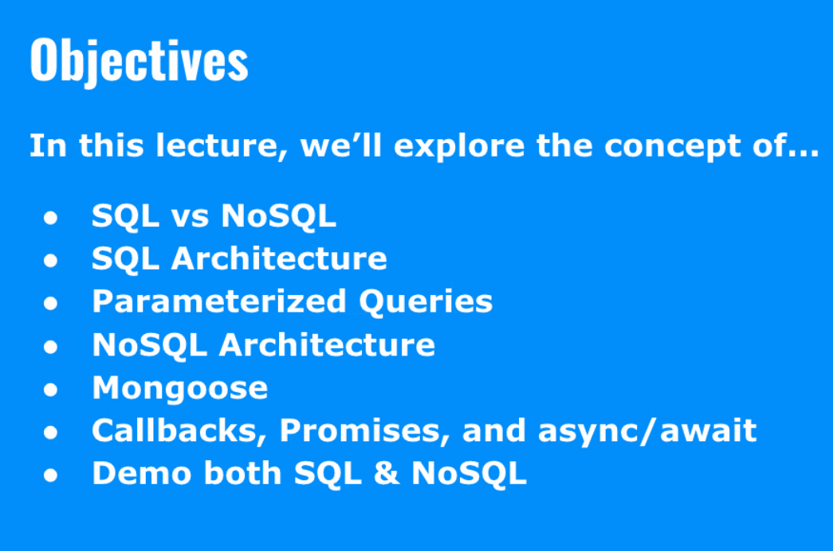

SQL vs NoSQL
SQL has predefined schemas; the tables are defined upfront before you insert data.
SQL is a vertically scaled language. If you scale them, you will have to use more hardware.
ACID compliant - ideal for complex transactions
A - Animosity, which is all or nothing. When a transaction occurs, it makes sure all the operations are completed successfully or none of them will
C - Consistency is only data that has predefined roles will be written to the database
I - Isolation concurrently control; transactions occur independently without interference from other concurrent transactions; Only one person can update the database at a time.
D- Durability if a transaction succeeds then the data will be written
NoSQL is horizontally scaled.
- Annie: Dropping this book rec as it sounds like Kim just started to touch on this, before the ACID pivot: System Design Interview – An insider's guide by Alex Xu. Very good for a high-level system design overview.
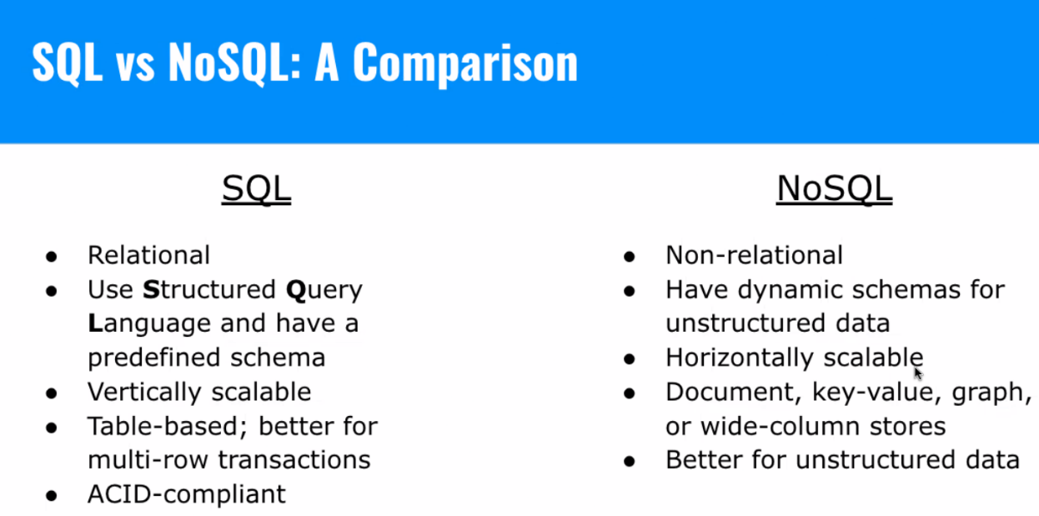

SQL databases you must map out the ER Diagram first
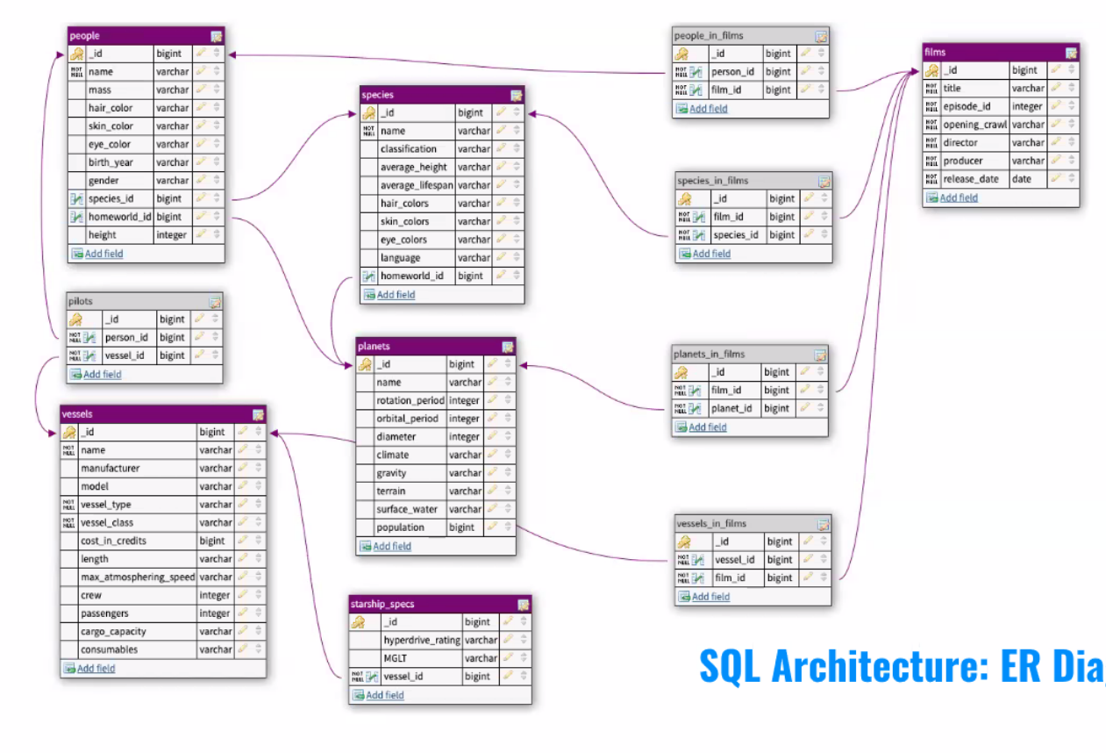
Primary Key - uniquely identifies rows
Foreign Keys - establishes relationships between two columns.

Below is the structure of the people table not the actual table.
The left side is the column names
On the right side is the datatype they must be inserted
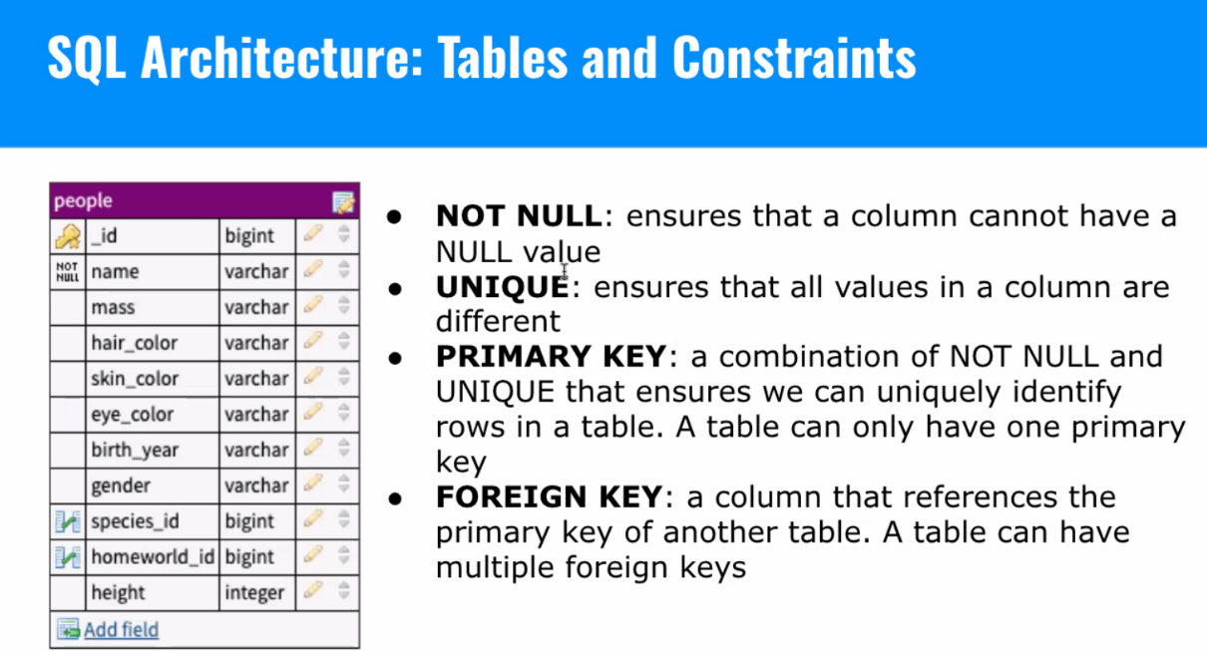
What the people table looks like
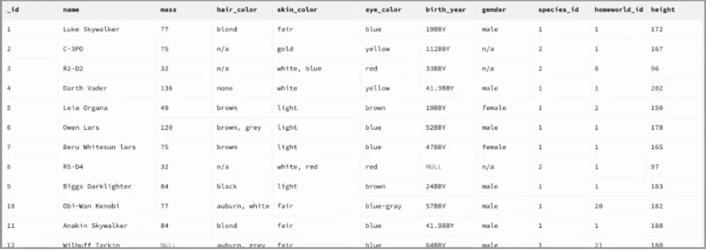

Parameterized Queries vs Template Literals
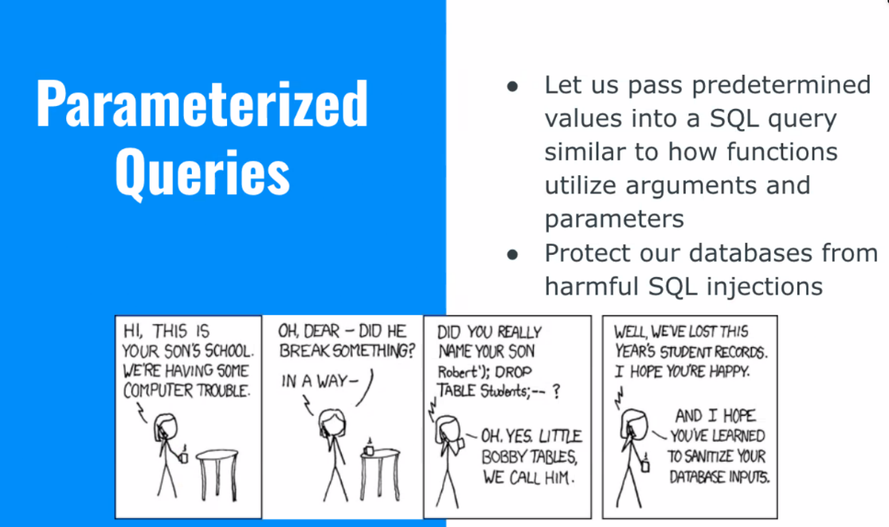

Template literals
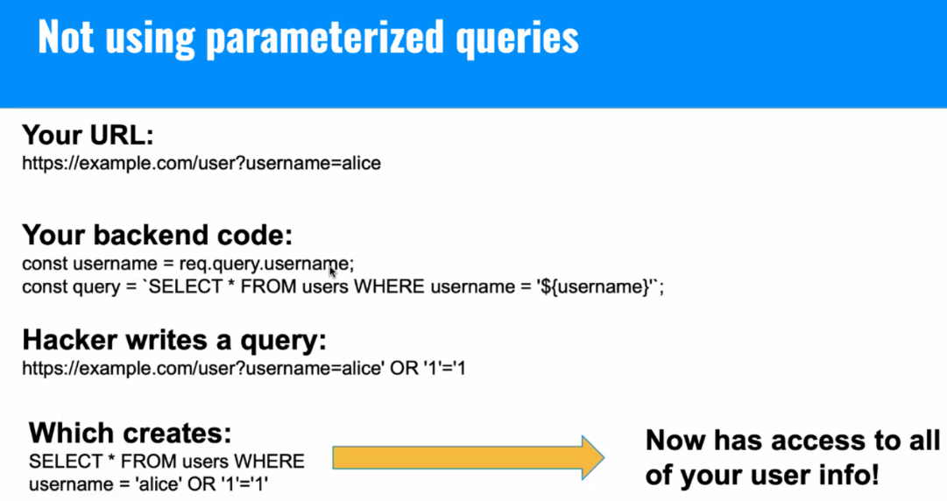

Parameterized Query: Example
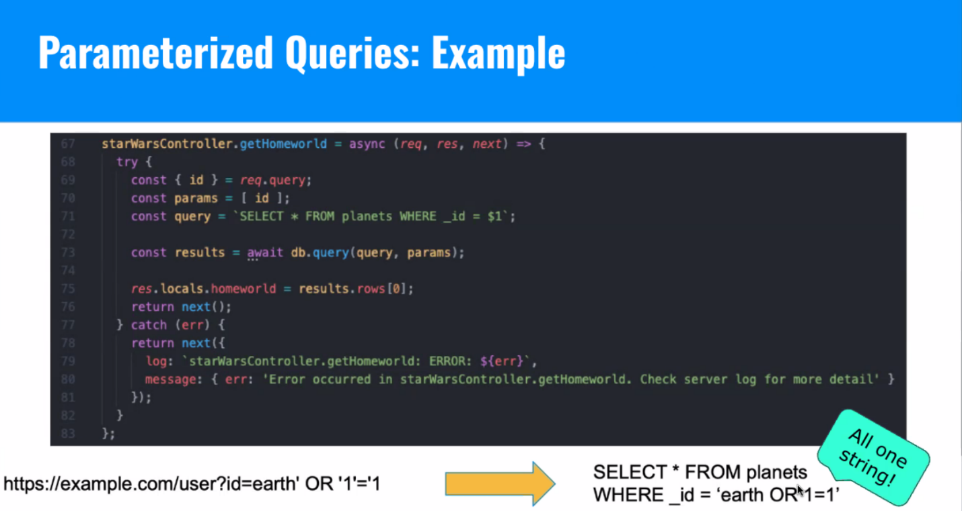
Line 70:
- Laynie - Creating a params variable assigned to the value of the id string in an array
- Christian - the query method syntax is .query(string, [options]) so we’re putting the id in an array
- Kevin - in this case since its only one param you can also write it the following way: const results = await db.query(query,[id]); or await db.query(query,[id,name,age]); if you want to write it long way. or the super long way db.query(`select * from planets where _id = $1`,[id]).

Different ways to write queries
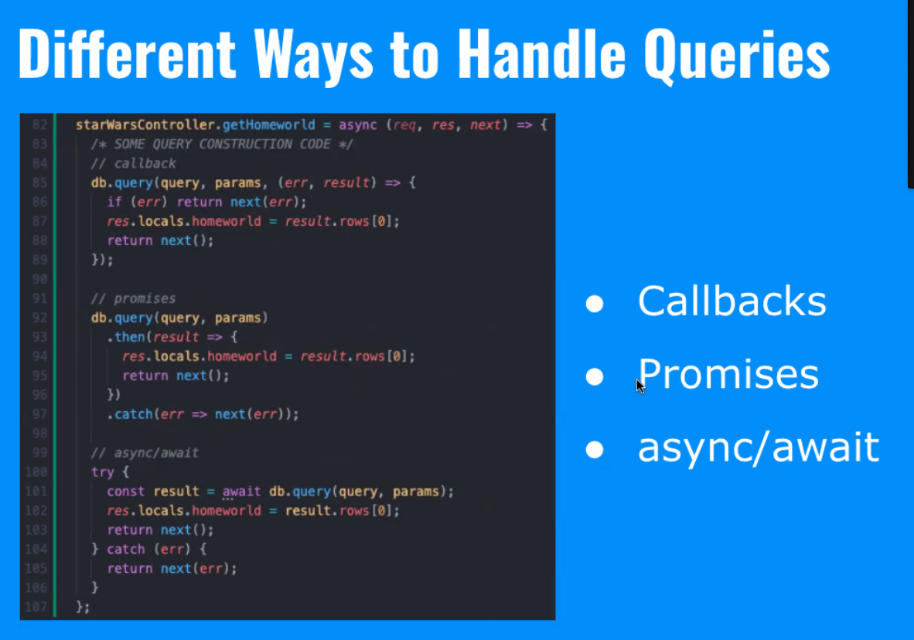
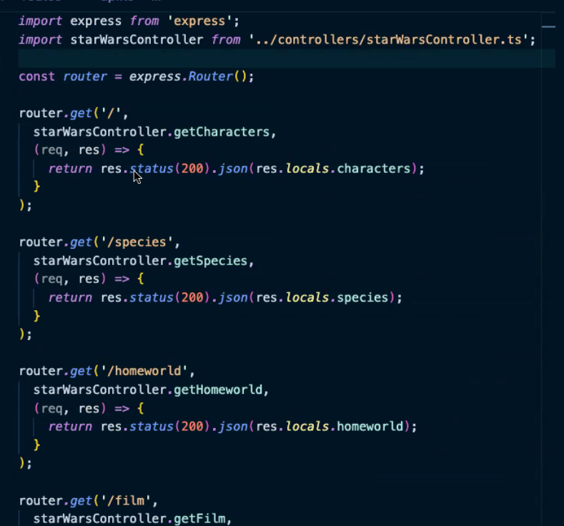

Models
With the .env file and git ignore
- You can store secret info in the .env file, and you can reference it by importing it (dotenv), and access it through
- AND you must remember to add it to gitignore, else the .env file would be uploaded to GitHub
Ssl: rejectUnauthorized:false} = we want to ignore our ssl being encrypted
- When in production, we WANT that to happen
- But when working in our basic environments, we set ssl to false
- This syntax apparently changes all the time, so I must look up the docs
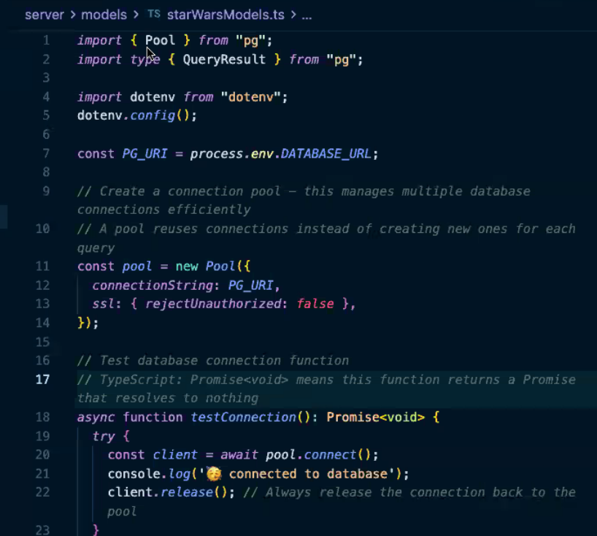
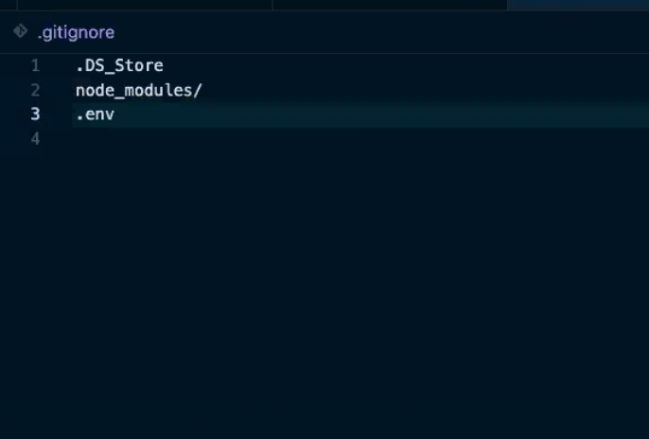

Test database. Connect to the pool then release the connection to ensure that you are connected. It is a sanity check
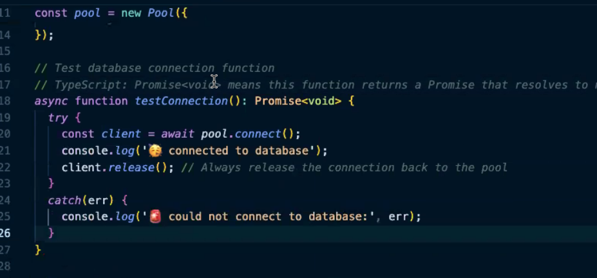

Pool reuses connections and keeps the connection open
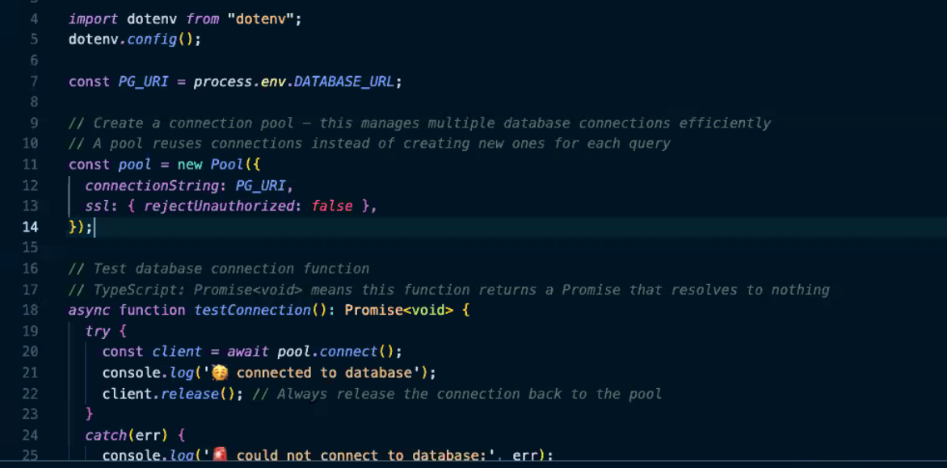

This function is a wrapper function that is going to set up our queries.
Text is string to pass to our database,
params is an option and an array and returns a promise.
Then we are returning the evaluated result of querying our pool with those parameters
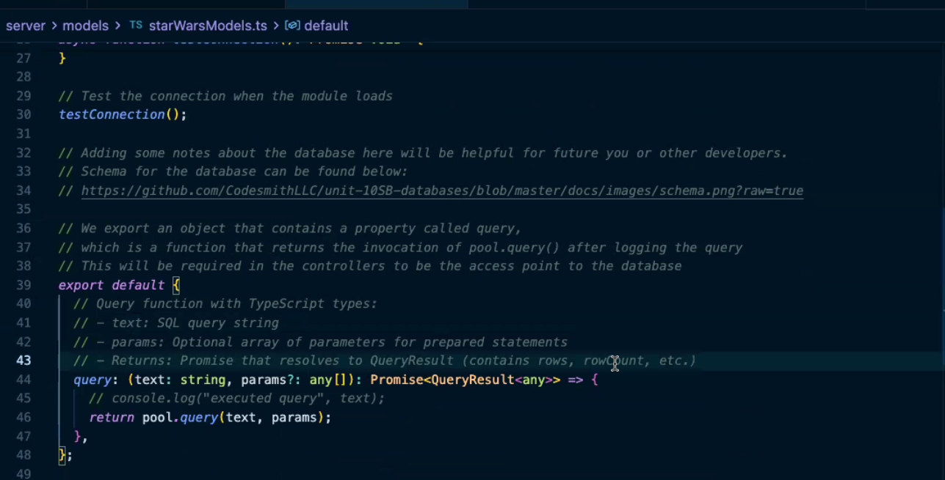

Star Wars Controller
Our interface structures our character and all our methods in our controller
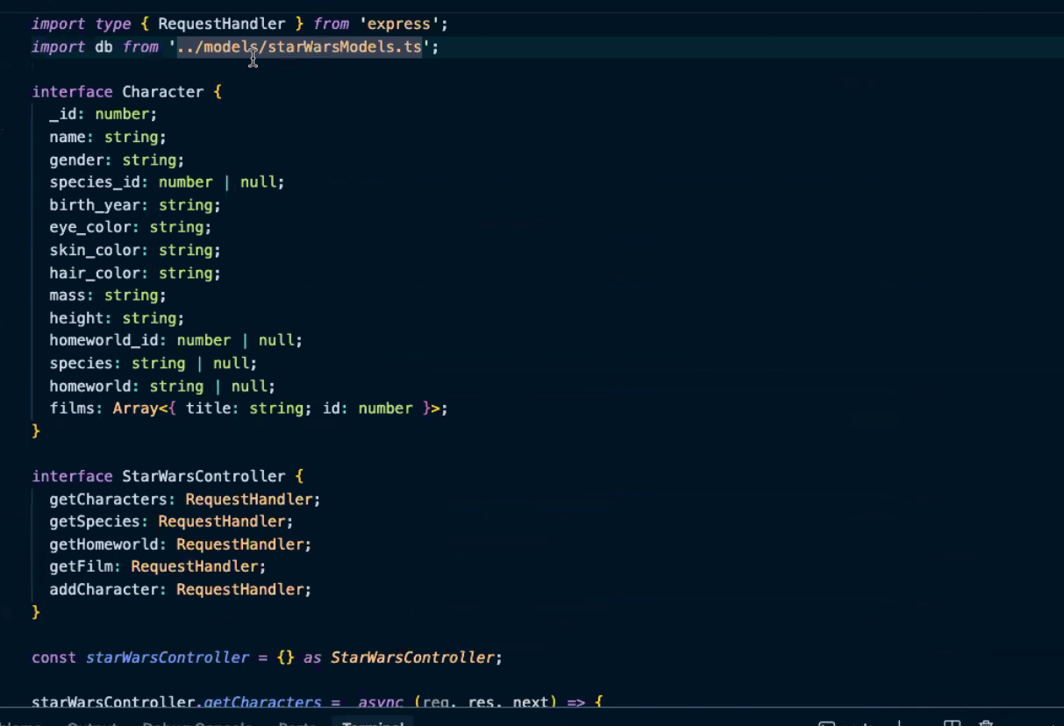

Type assertion is the const starwarsController ={} as Star Wars controller
Get characters PostgreSQL middleware with the get films subquery

We grab all the characters then we loop to get the films that they have been in then we query again
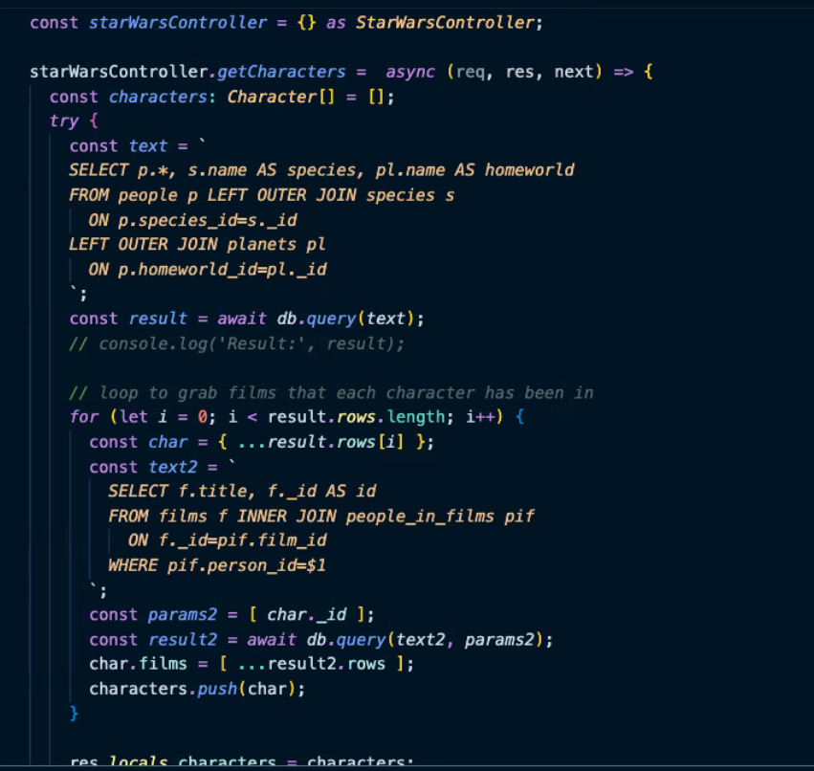

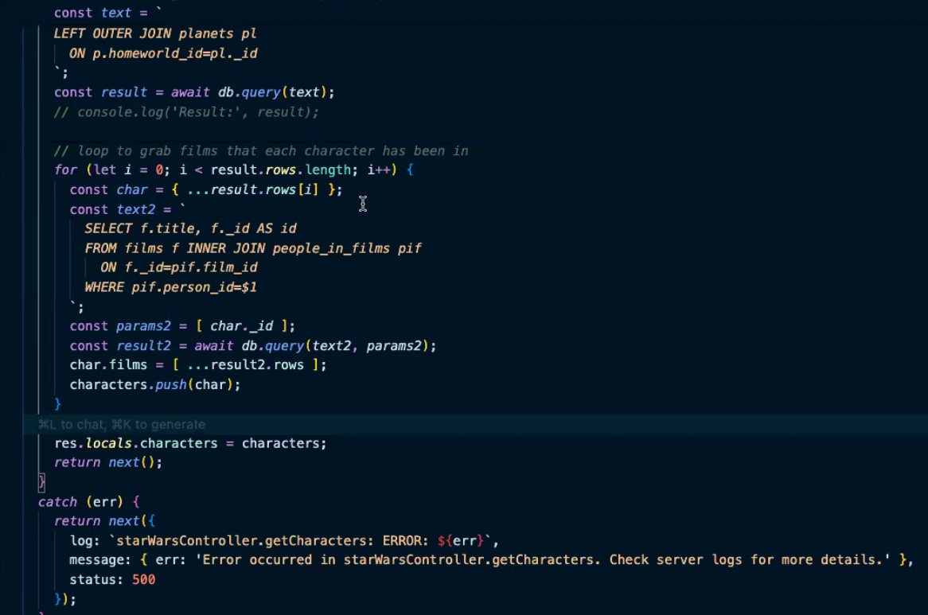

Get films PostgreSQL
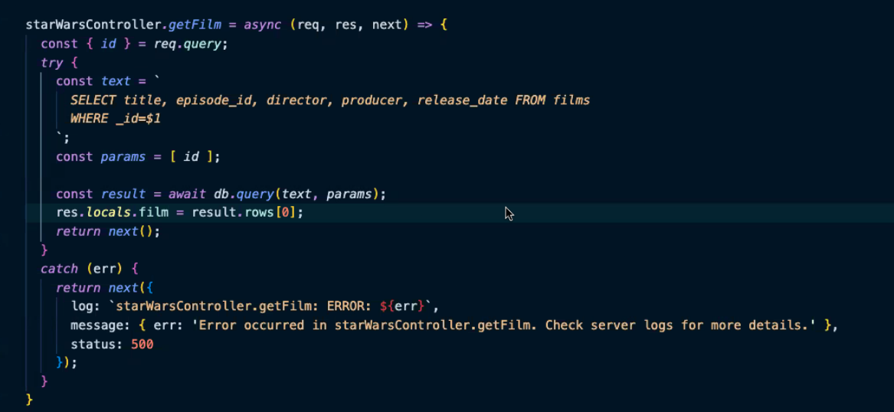

Get Species middleware function
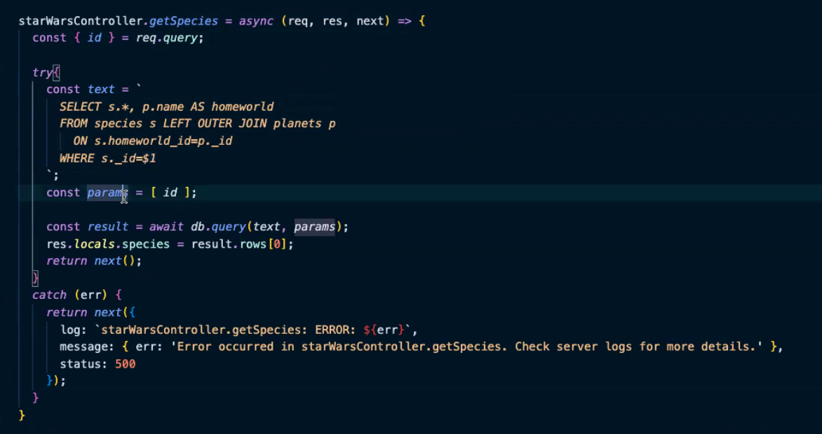

Get Homeworld middleware function
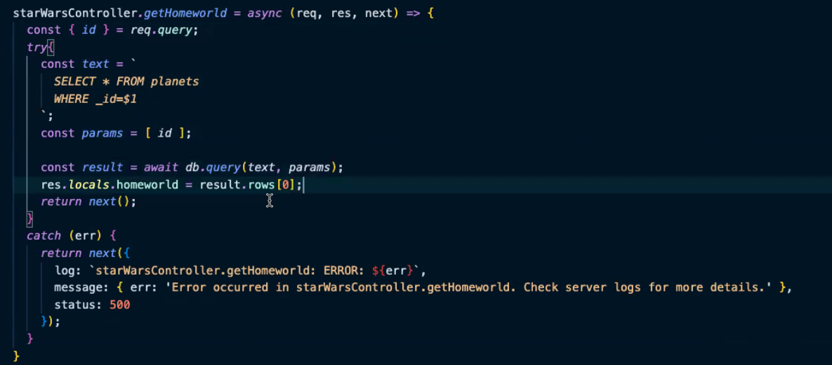

NoSQL Architecture: MongoDB
- Every document must have a unique ID, which Mongo will automatically assign
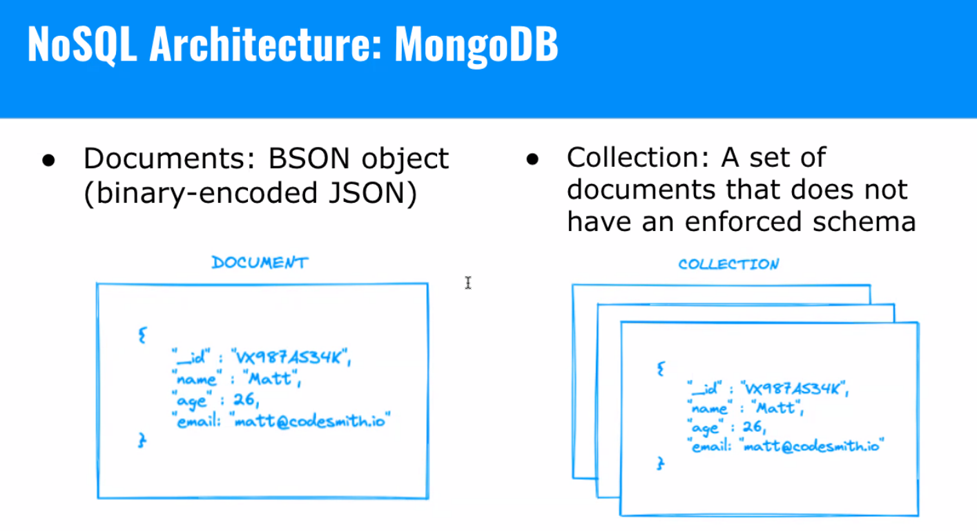

MongoDB is a box
Inside MongoDB is a collection which are folders
Inside Collections are documents
MongoDB does not require you to define a schema ahead of time

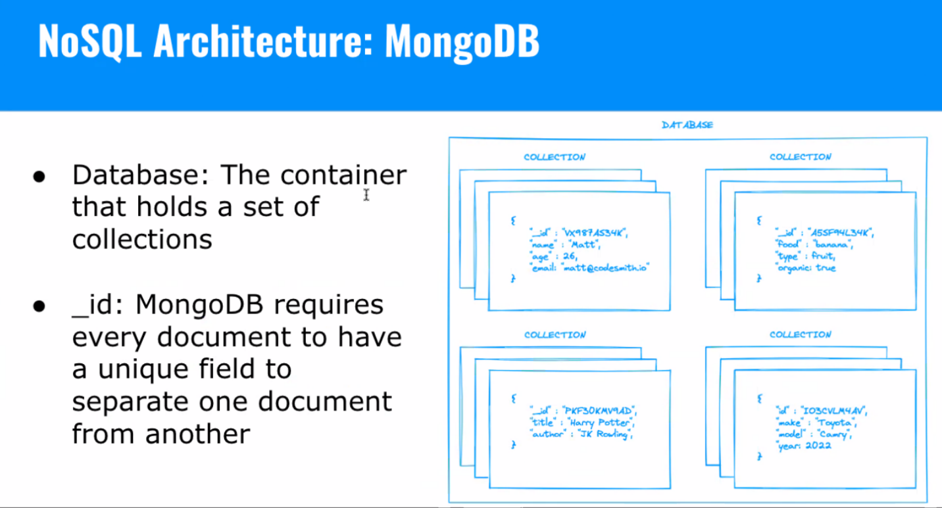

Mongoose
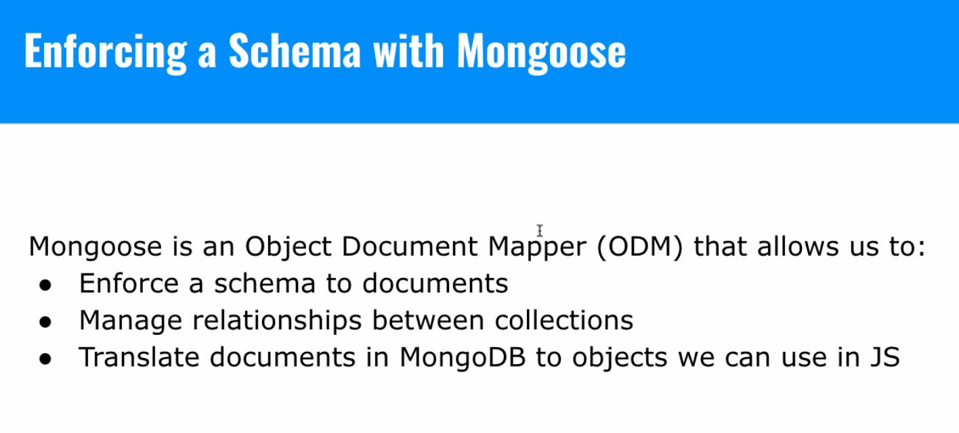

- The big difference between SQL and NoSQL is that mongo doesn’t require you to set up a schema ahead of time (nor ER tables)
- However, if you want to enforce the schema, which often you do, you’ll use a library called Mongoose

Schema is an interface
Enforcing a schema with mongoose
We create Schema (structures) using the schema constructor then we can specify the data types and relationships

Model is objects
THEN we create models that allow us to enforce our structure for our data
Model also includes methods that allow us to interact with the database
The model provides CRUD for our database
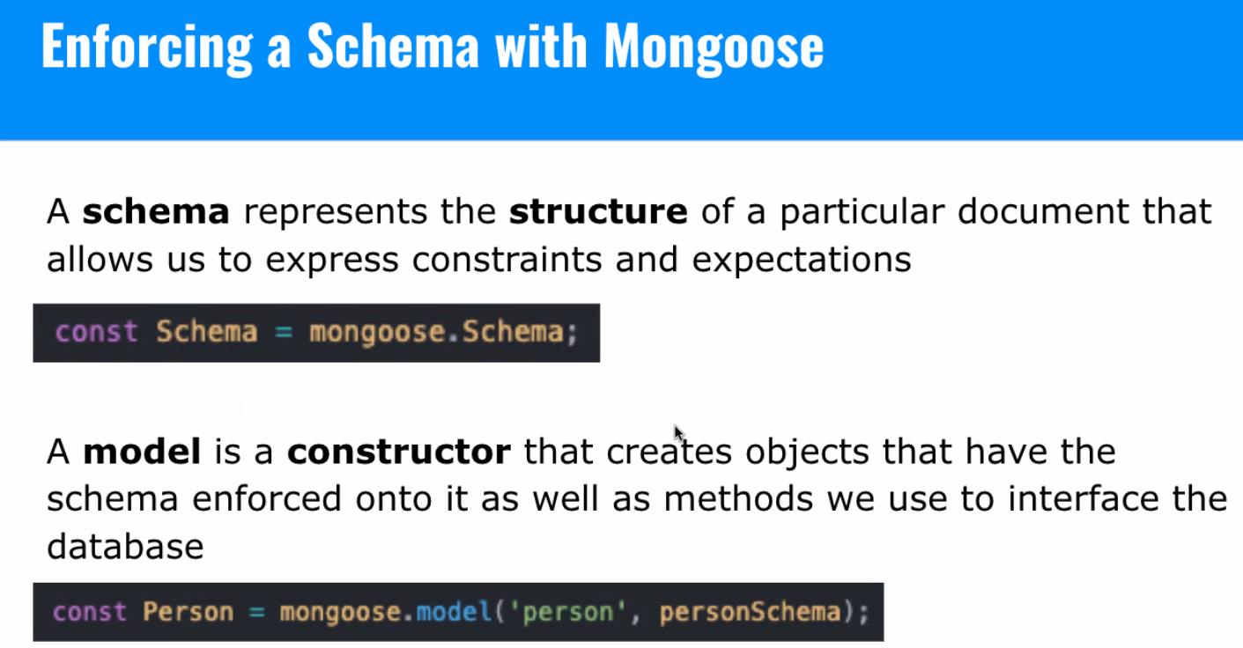
- We are creating schemas (aka structures) for our data. To create that schema, we are using the Mongoose Schema constructor (blueprint). Defining the shape of the documents that’ll be in the collection.
  - Defining required, default values, etc.
  - The Schema doesn’t directly interact with the database and is not performing any operations
  - A model, on the other hand, creates objects that have the schema we’ve told it to enforce.
    - Models also include methods that let us interact with the DB.
    - The model is how we perform CRUD operations
  - Delilah - Schema = like Ikea blueprint, model = the friend who reads the blueprint, so you don’t have ‘extra’ pieces?
- Mongoose automatically pluralizes collections as well.
- The schema doesn’t let us interact with the DB, but the model does.

Mongoose Star Wars Models files

Mongoose Schema for species - Setting up different Schemas - the blueprints. So, we’re creating a new instance of Schema, and we’re telling mongo/mongoose, assigning the types, and we are setting foreign keys too. The ref is telling Mongoose what other model Monto will be referencing. Lines 27-34 = how to set up a foreign key relationship
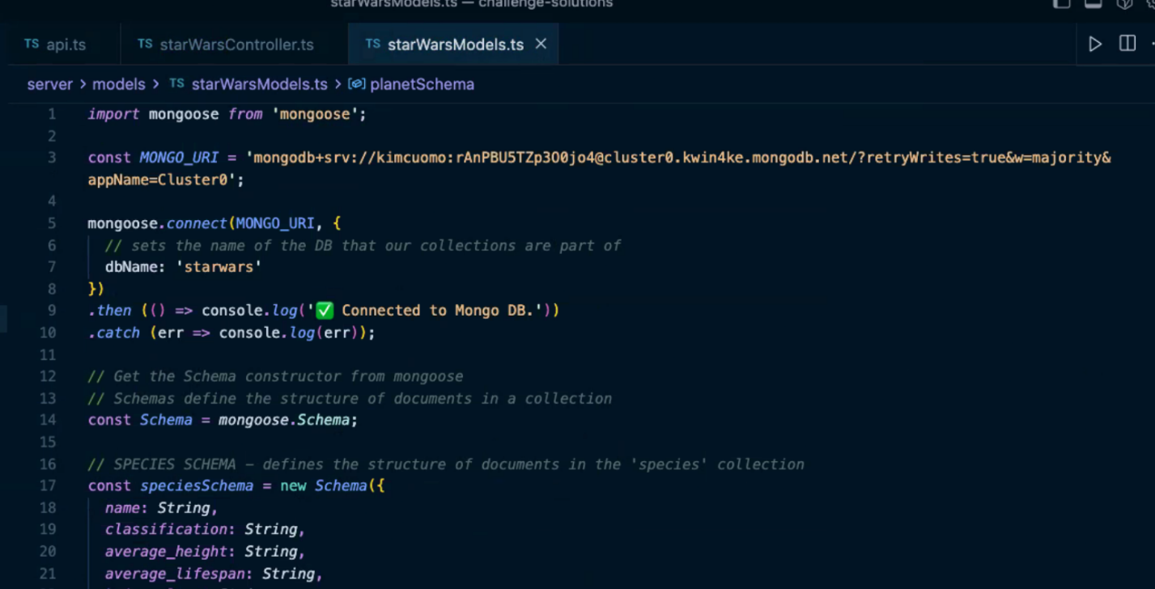
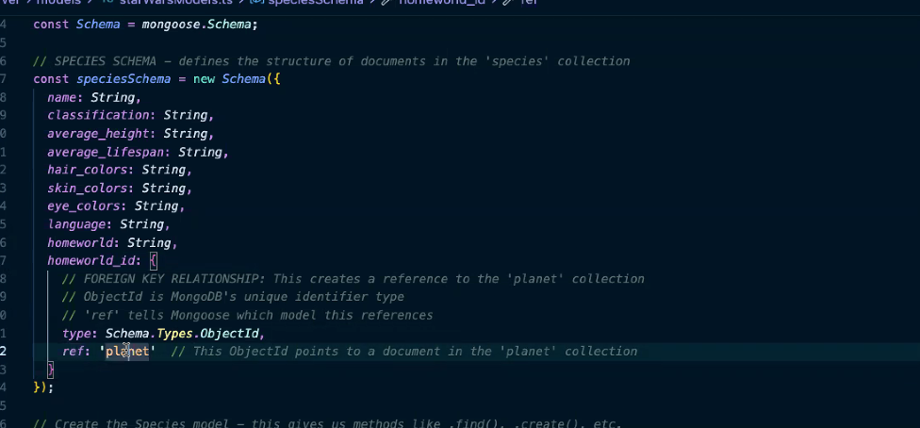

Mongoose model for species
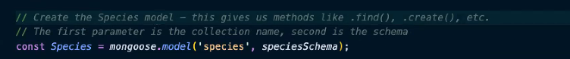

Planet
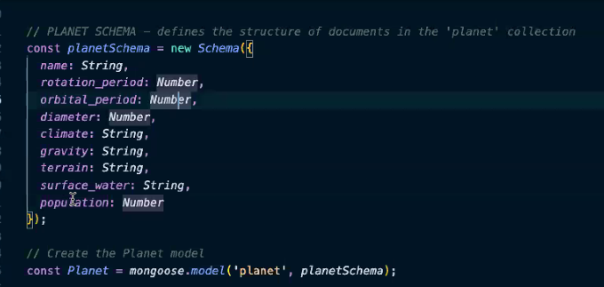

Film
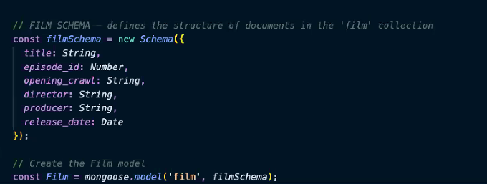

Person
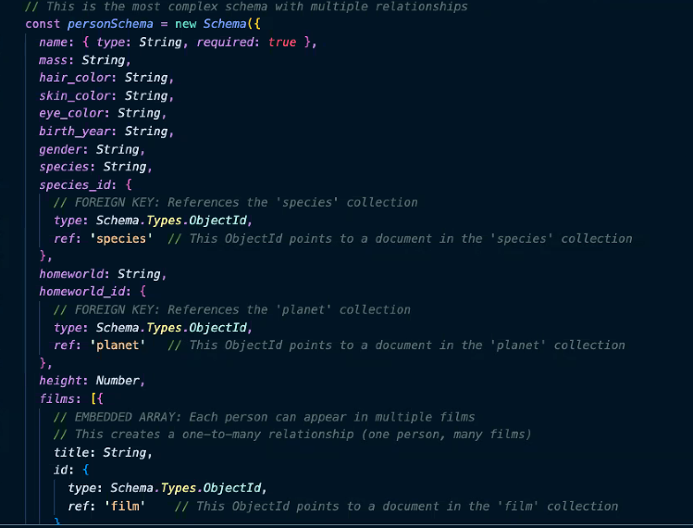

Person Model
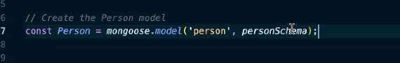

Export models
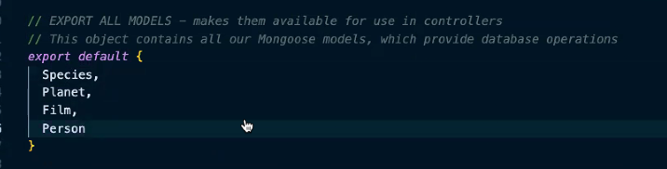

Mongoose Star Wars controller
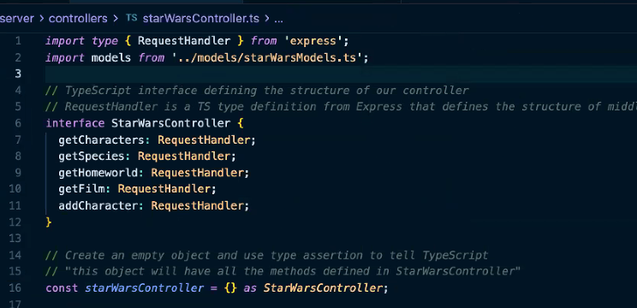

Get characters (non-nested)
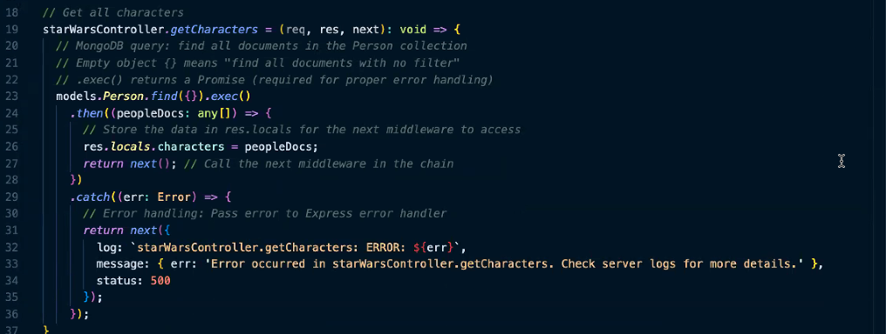

Get species by id
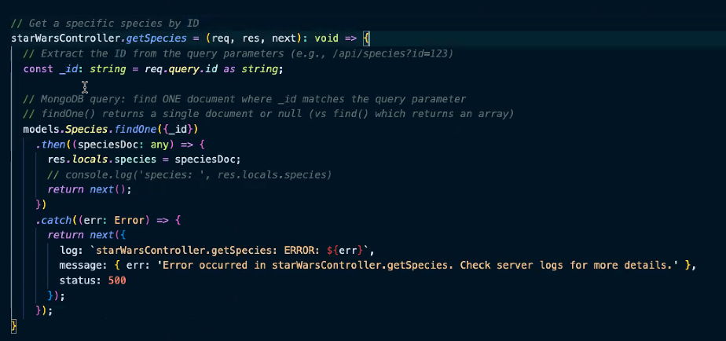

Get home world by id
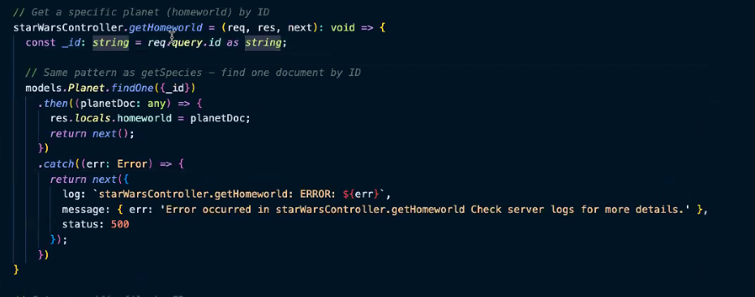
Note the difference between find and find One
- Find method = we want them all (could also add filtering)
- FindOne = we find one, but it’ll only know which one to look for by passing in the (_id_)
Get film by id
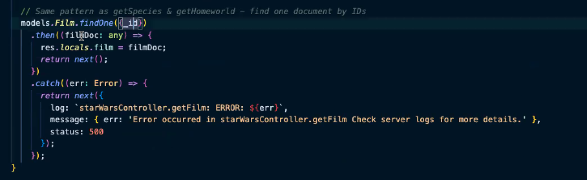

Add character
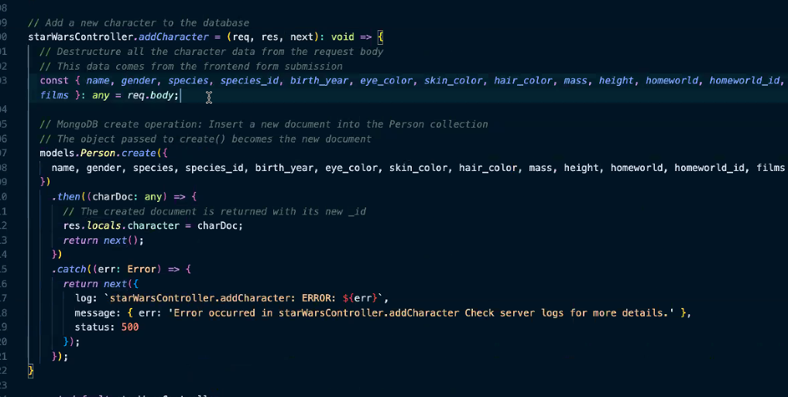
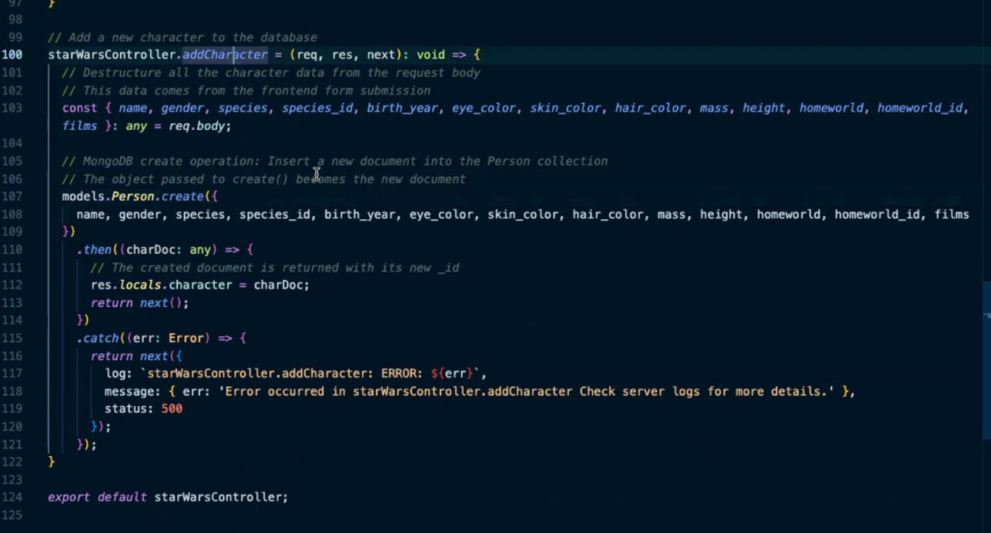
- AddChar - a more complicated one
  - First, destructuring all the individual pieces from the body
- Info comes in from the form through the body, then pulled it off from the request, and then pass it into the create method
- THEN we receive something back, storing the data acquired to res.locals
- On the front end, it takes the data and populates it into a new card
- For consistency, we should add .exec() to all queries so they all explicitly return Promises:
  - Since we’re using thens here, the code worked, but if we used async/await, we need to use .exec()
DB assessment info:
- If you’ve not played around with Mongo and Mongoose at all, try to do that today.
- Just go through that part of the challenge from the beginning.
- We will be using mongo and mongoose on the assessment
  - Think of CRUD operations

